**Global Development Analysis Report**

**Project Overview**

This project analyzes key global development indicators across countries, covering GDP, population, literacy, mortality, and migration. The goal was to create an interactive Power BI dashboard system that explores patterns, identifies disparities, and supports decision-making for social and economic policy.

**Data Sources**

* **Countries-World Dataset**: Core development indicators like literacy, birth/death rate, GDP per capita
* **World Bank GDP Data (1960–2016)**: Year-wise GDP
* **Population Dataset**: Year-wise population by country
* **Metadata**: Region and Income Group classification for each country

**Data Processing**

**Data Cleaning:**

* Renamed inconsistent columns
* Removed global summary rows (e.g., "World", "High Income")
* Converted fractional rates to correct scale (e.g., birthrate × 1000)
* Trimmed country names, removed nulls and invalid entries

**Data Transformation:**

* Unpivoted GDP and population year columns for time-series analysis
* Merged tables on Country and Year to align GDP with population
* Linked regional metadata to each country
* Created DAX measures for KPIs (Growth %, GDP per capita, literacy average, etc)

**DASBOARD**

**1.Global Economic Over Time**

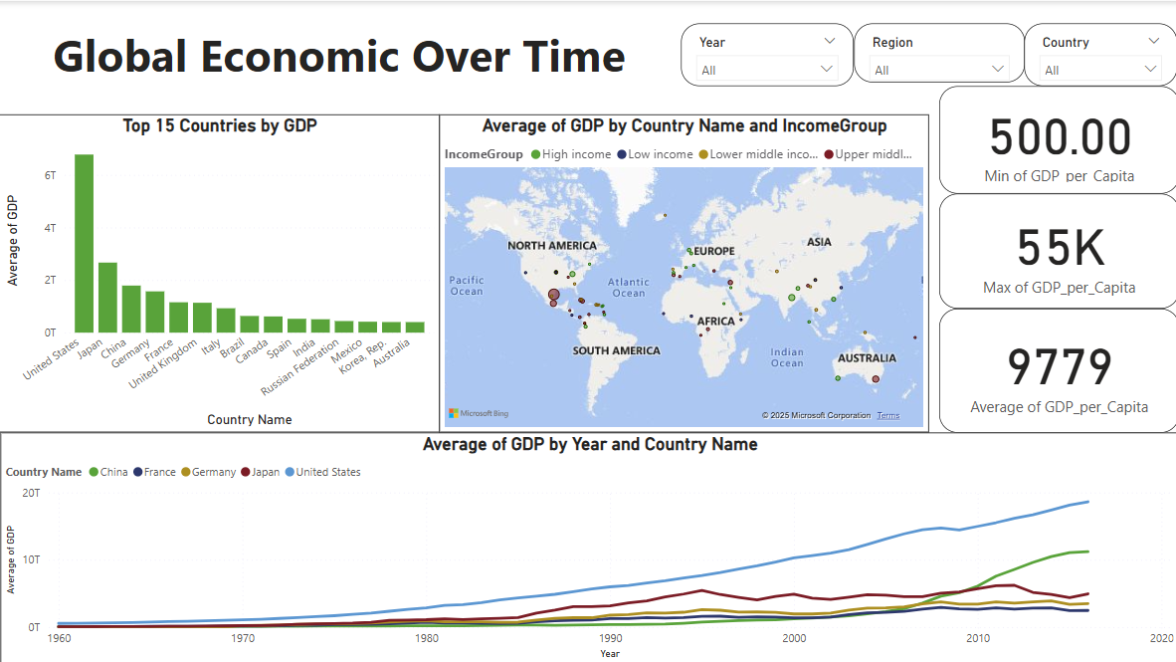

**2.Population Trends & Growth**

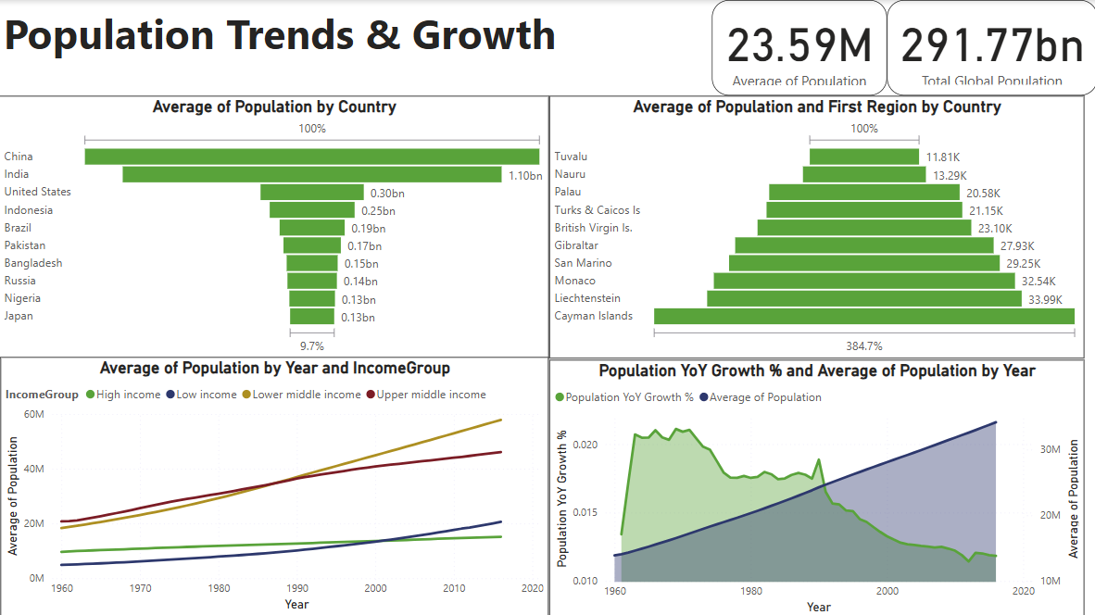

**3. Literacy Rate Analysis**

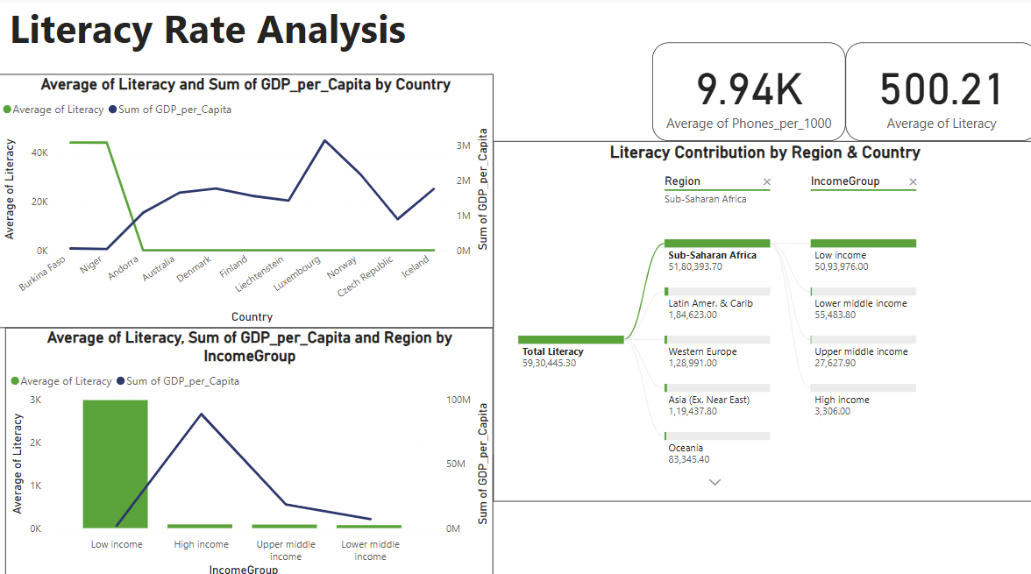

**4.** **Regional Comparisons**

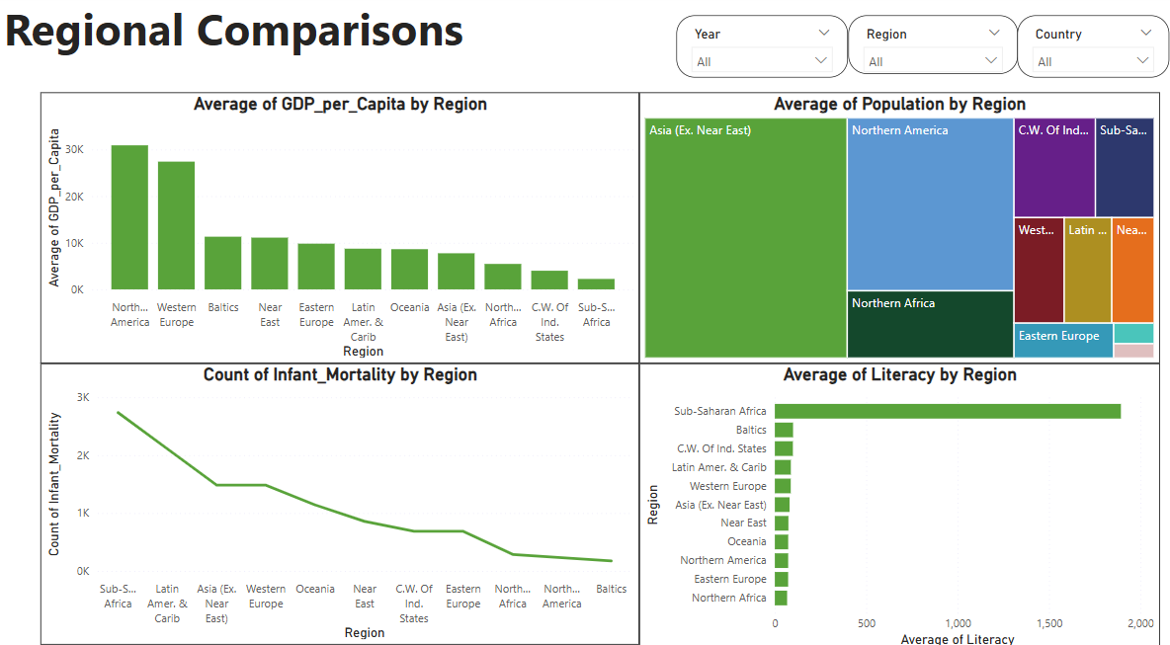

**5. Country Deep-Dive Explorer**

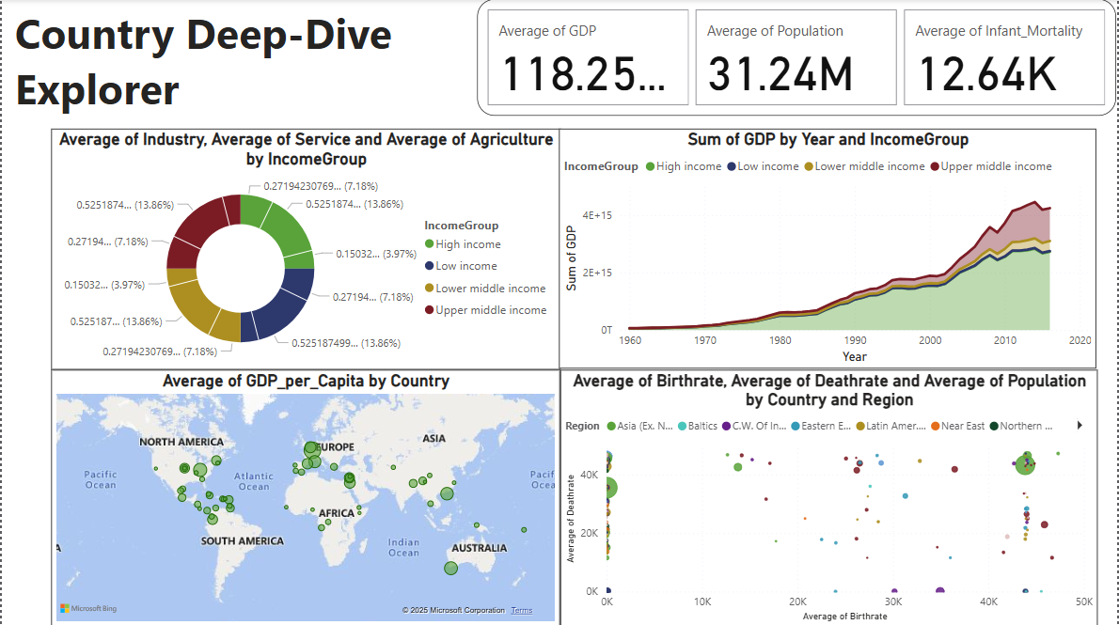

**6.** **Emigration Analysis**

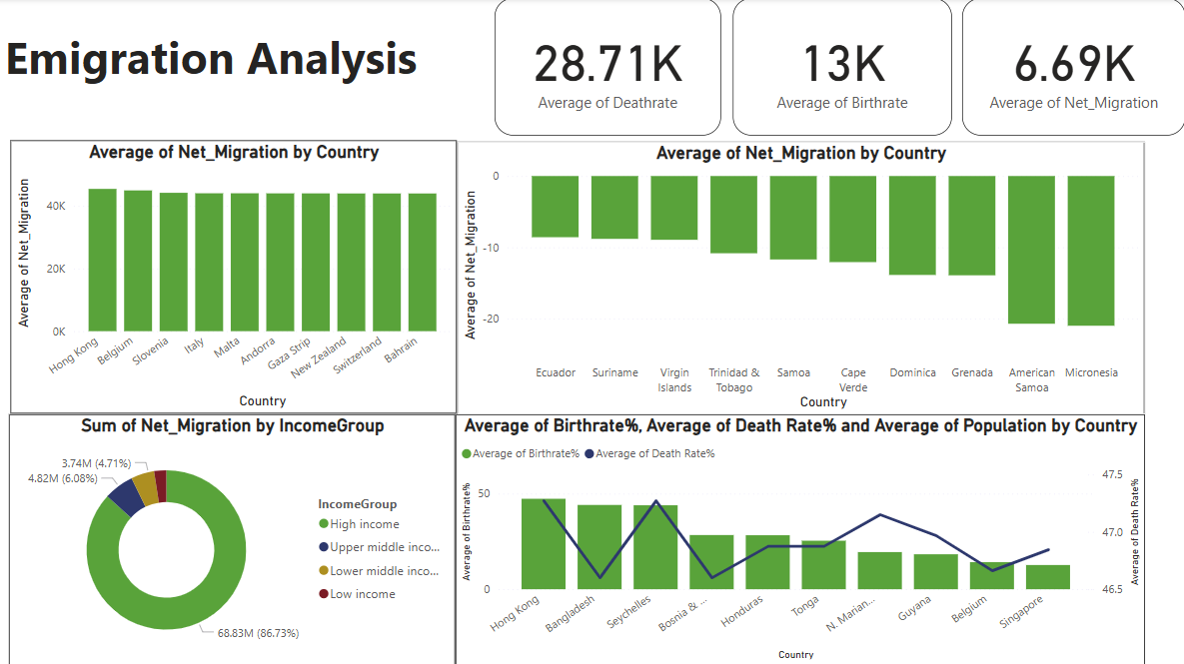

**Key Insights**

* Unequal Growth: A few countries dominate GDP while many remain economically underdeveloped.
* Literacy Inequality: Literacy rates are closely tied to income. Sub-Saharan Africa has the lowest.
* Population Pressure: High growth rates in low-income countries strain resources.
* Digital Divide: Phone access is far higher in high-literacy and high-GDP nations.
* Infant Mortality: Still a major issue in low-income regions despite global healthcare progress.
* Migration Patterns: Richer nations attract more migrants, poorer nations see outflows.

**Recommendations**

1. Invest in Education: Low-literacy countries should receive international support for school access and teacher training.
2. Promote Digital Access: Increase infrastructure for affordable mobile and internet access in developing nations.
3. Targeted Health Programs: Reduce infant mortality through vaccination, clean water, and maternal care.
4. Sustainable Urban Planning: High-growth countries must plan housing, jobs, and transport infrastructure accordingly.
5. Support Equitable Trade: Encourage partnerships that benefit low-GDP nations with inclusive economic policies.

**Conclusion**

This analysis uncovers the gaps and opportunities in global development. While many countries show progress in economic and educational dimensions, others face systemic challenges. The dashboard offers a powerful tool for policymakers, educators, and international organizations to drive impactful change based on data-driven insights.